Opinion | OP-ED COLUMNIST

Anne Frank Today Is a Syrian Girl
Nicholas Kristof AUG. 25, 2016
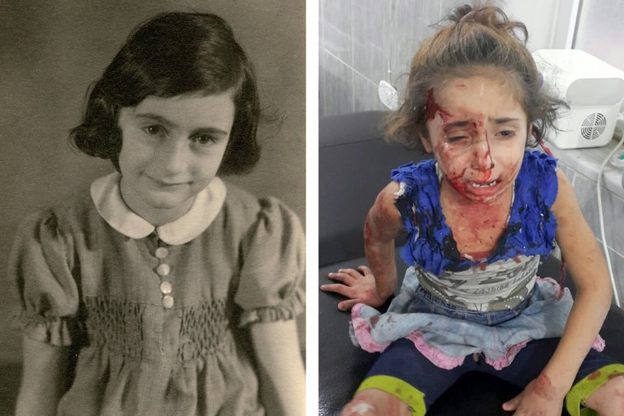
Anne Frank, left. At right, Rouwaida Hanoun, a Syrian 5-year-old who was wounded during an airstrike on Aleppo last week. CreditLeft, Anne Frank Fonds — Basel, via Getty Images
AMSTERDAM — On April 30, 1941, a Jewish man here in Amsterdam wrote a desperate letter to an American friend, pleading for help emigrating to the United States.
“U.S.A. is the only country we could go to,” he wrote. “It is for the sake of the children mainly.”
A volunteer found that plea for help in 2005 when she was sorting old World War II refugee files in New York City. It looked like countless other files, until she saw the children’s names.
“Oh my God,” she said, “this is the Anne Frank file.” Along with the letter were many others by Otto Frank, frantically seeking help to flee Nazi persecution and obtain a visa to America, Britain or Cuba — but getting nowhere because of global indifference to Jewish refugees.
We all know that the Frank children were murdered by the Nazis, but what is less known is the way Anne’s fate was sealed by a callous fear of refugees, among the world’s most desperate people.
Sound familiar?
President Obama vowed to admit 10,000 Syrian refugees — a tiny number, just one-fifth of 1 percent of the total — and Hillary Clinton suggestedtaking more. Donald Trump has repeatedly excoriated them for a willingness to welcome Syrians and has called for barring Muslims. Fears of terrorism have left Muslim refugees toxic in the West, and almost no one wants them any more than anyone wanted a German-Dutch teenager named Anne.
“No one takes their family into hiding in the heart of an occupied city unless they are out of options,” notes Mattie J. Bekink, a consultant at the Anne Frank House in Amsterdam. “No one takes their child on a flimsy boat to cross the Mediterranean unless they are desperate.”
The son of a World War II refugee myself, I’ve been researching the anti-refugee hysteria of the 1930s and ’40s. As Bekink suggests, the parallels to today are striking.
For the Frank family, a new life in America seemed feasible. Anne had studied English shorthand, and her father spoke English, had lived on West 71st Street in Manhattan, and had been a longtime friend of Nathan Straus Jr., an official in the Franklin Roosevelt administration.
The obstacle was an American wariness toward refugees that outweighed sympathy. After the 1938 Kristallnacht pogrom against Jews, a poll found that 94 percent of Americans disapproved of Nazi treatment of Jews, but 72 percent still objected to admitting large numbers of Jews.
The reasons for the opposition then were the same as they are for rejecting Syrians or Hondurans today: We can’t afford it, we should look after Americans first, we can’t accept everybody, they’ll take American jobs, they’re dangerous and different.
“The United States, if it continues to be the world’s asylum and poorhouse, would soon wreck its present economic life,” the New York Chamber of Commerce warned in 1934.
Some readers are objecting: But Jews weren’t a threat the way Syrian refugees are! In the 1930s and ’40s, though, a world war was underway and Jews were widely seen as potential Communists or even Nazis. There were widespread fears that Germany would infiltrate the U.S. with spies and saboteurs under the cover that they were Jewish refugees.
“When the safety of the country is imperiled, it seems fully justifiable to resolve any possible doubts in favor of the country, rather than in favor of the aliens,” the State Department instructed in 1941. The New York Times in 1938 quoted the granddaughter of President Ulysses S. Grant warning about “so-called Jewish refugees” and hinting that they were Communists “coming to this country to join the ranks of those who hate our institutions and want to overthrow them.”
News organizations didn’t do enough to humanize refugees and instead, tragically, helped spread xenophobia. The Times published a front-page article about the risks of Jews becoming Nazi spies, and The Washington Post published an editorial thanking the State Department for keeping out Nazis posing as refugees.
In this political environment, officials and politicians lost all humanity.
“Let Europe take care of its own,” argued Senator Robert Reynolds, a North Carolina Democrat who also denounced Jews. Representative Stephen Pace, a Georgia Democrat, went a step further, introducing legislation calling for the deportation of “every alien in the United States.”
A State Department official, Breckinridge Long, systematically tightened rules on Jewish refugees. In this climate, Otto Frank was unable to get visas for his family members, who were victims in part of American paranoia, demagogy and indifference.
History rhymes. As I’ve periodically argued, President Obama’s reluctance to do more to try to end the slaughter in Syria casts a shadow on his legacy, and there’s simply no excuse for the world’s collective failure to ensure that Syrian refugee children in neighboring countries at least get schooling.
Today, to our shame, Anne Frank is a Syrian girl.

